**AI on the Edge: The Power Couple Transforming Industries**

Imagine a world where factory machines predict their own failures, self-driving cars react to hazards in milliseconds, and smart cities optimize traffic flow in real-time. This isn't science fiction; it's the future powered by the dynamic duo of artificial intelligence (AI) and edge computing.

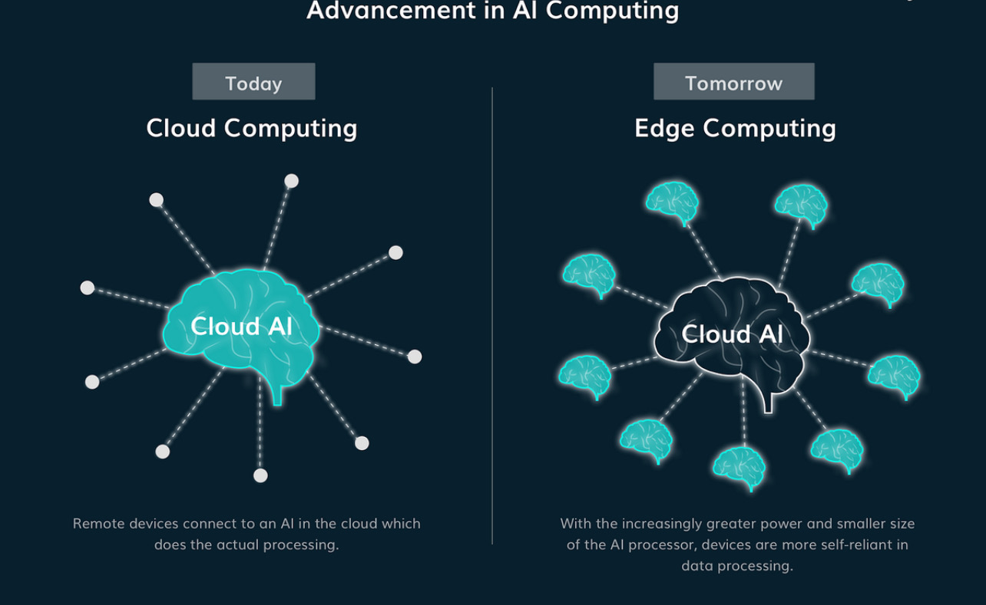

**Why Go to the Edge?**

In the past, AI has sent data to centralized cloud computing centers for processing. But there are limits to this approach. Latency, the time it takes for data to travel, becomes a bottleneck for real-time applications. This is where edge computing comes into play. At the "**edge**" of a network, edge devices such as smart sensors and microdata centers are used to process local information. This significantly reduces the lag time. According to Gartner, **75 %** of the data will be handled at the edges by 2025.

**EDGE AI Workflow**

1. **Data Collection:** Sensor devices and machines collect data at the network's "edge." This data can include temperature readings, video footage, or machine performance metrics.
2. **Pre-processing:** Edge devices often perform basic data cleaning and filtering to reduce the data volume before further processing.
3. **AI Inference:** Powerful AI models, optimized for edge devices, analyze the preprocessed data to extract meaningful insights or make real-time decisions.
4. **Action or Communication:** Based on the AI's results, the edge device can take actions (like adjusting a machine setting) or communicate with other devices or a central server.

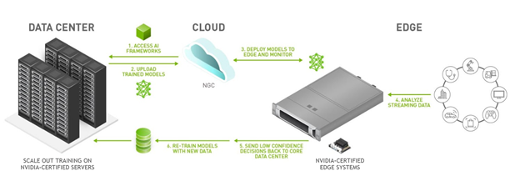

**The Power of the Partnership**

Now, combine the power of edge computing with AI, and you have a game-changer. Here are a few ways this powerful couple is transforming industries:

* **Predictive Maintenance**: In manufacturing, sensor data from equipment can be analyzed by AI at the edge to predict failures before they occur. This can prevent costly downtime and optimize maintenance schedules. A study by McKinsey Digital Labs found that predictive maintenance powered by AI can reduce downtime by up to 50%.
* **Real-Time Decision Making**: In self-driving cars, AI running on edge devices can analyze sensor data from cameras and LiDAR systems to make critical decisions in milliseconds, enabling faster reaction times and safer navigation.
* **Smart Cities**: Edge AI can analyze data from traffic cameras and sensors to optimize traffic flow, reduce congestion, and improve overall city efficiency. A report by IDC estimates that smart city initiatives using AI can generate up to **$3.1 trillion** in global economic value by 2025.

**The Future is Intelligent and Distributed**

Intelligent, distributed systems are the future. We can look forward to even more inventive applications that will change our way of life, work and interaction with the world as artificial intelligence and edge computing develops. There are truly limitless possibilities here. The exciting journey of AI and edge computing is only beginning